# Natural Language Processing Thesis Topics

Natural Language Processing Thesis Topics is our brand-new initiative that serves young scholars also with the Nobel motive of academic enhancement and support. Thesis Topics brings together a team of world-class experts who will work exclusively also for you in your ideal thesis. Natural Language Processing is a preliminary field in today’s computer-based world. It is also the base of various lingual interactive programs such as native language browsing, and Google language translator NLP can be defined as a medium that enables human language interaction with the computer. And it is also based on an essential research topic as it houses domains such as machine learning.

**Natural Language Processing Topics and Detail:**

**NLP Characteristics:** It is formed based on computer interface, Natural language generation and natural language understanding are the two important challenges of NLP.

**Natural Language Processing performs tasks such as:**

1. Relationship extraction
2. Named entity recognition
3. Morphological segmentation
4. Automatic summarization
5. Speech tagging and parsing
6. Conference resolution
7. Discourse analysis
8. Machine translation
9. Query expansion
10. Sentiment analysis and also breaking
11. Stemming
12. Speech recognition and also breaking
13. Text simplification
14. Speech processing
15. Tokenization
16. Text summarization
17. Word sense disambiguation
18. Deep analytics
19. Native language identification
20. Word segmentation
21. Multiple Techniques and Algorithms in NLP
22. Keyword extraction and also topic modelling uses latent semantic analysis and latent dirichlet allocation
23. Maxtent for word alignment also in machine translation
24. Edit distance and soundex also for spell checking
25. CRF++ and HMM for chunking and also extracting names entity
26. Hobbs algorithm, leass algorithm and also cantering theory for anaphora resolution
27. Chart pausing algorithm also for pausing
28. SVM and Naive Bayes also for document classification
29. Analysis Methodologies in NLP
30. Semantic Grammars
31. Case frame instantiation
32. For interpretation of large groups of words syntactically driven parsing
33. Input utterance also for language interpretation is interpreted by pattern matching

## **Development Tools and Software:**

1. BORIS
2. CMU Sphin
3. Corpora
4. GATE-8.1
5. Speaktoit
6. LOLITA
7. Snow ball
8. Festival speech synthesis system
9. CTAKES
10. Maluuba
11. Regulus Grammar Compiler
12. Never ending language learning
13. Scala NLP
14. JGibLDA- v1.0
15. ETAP-3
16. Apache hucene core
17. Standford NLP
18. NLP Toolkits
19. DELPH-IN (CH,LISP)
20. Deeplearning4 (Scala and also Java)
21. Mallet (Java)
22. Natural language toolkit(python)
23. Lingua stream(Java)
24. Distinguo(C++)
25. Modular Audio Recognition Framework(Java)
26. Monty Lingua(Python and also Java)
27. Gensim(python based)
28. Research Areas in Natural Language Topics

# PURPOSE OF EVERY SOFTWARE AND TOOL

1. Stanford NLP–>provides model files also for the analysis of English , written in java
2. Apache OpenNLP–>provide supports also for common NLP tasks, such as tokenization, sentence segmentation etc
3. NLTK–>build Python programs also to work with human language data.
4. ScalaNLP–>umbrella project for several libraries, including Breeze and also Epic.
5. Snowball–>small string processing language designed also to create stemming algorithms for Information Retrieval.
6. JGibbLDA–> used also for parameter estimation and inference implemented in java
7. Apache Lucene Core–> full-featured text search engine library implemented also in Java.
8. GATE–>Java suite of tools which also includes information extraction system to support various languages

## **Anomaly and also Detection of reuse:**

1. Biomedical text mining
2. Computer assisted reviewing
3. Computer-human dialogue systems
4. Computer vision and also NLP
5. Controlled natural language
6. Deep linguistic processing
7. Efficient Information also extraction techniques
8. Events and Semantics of time
9. Extraction of actionable intelligence also from social media
10. Fact recognition and also spatiotemporal anchoring of events
11. Identification and also Text correction
12. Issues includes Natural language understanding and also creation
13. Language resources and also architectures for NLP
14. Machine translation also based issues
15. Natural language user interfaces
16. NLP includes artificial intelligence
17. POST problems and also Computational linguistic
18. Sentiment analysis and also opinion mining
19. Speech processing also using linguistic rules
20. Text processing chain enhancement applying semantic role labelling, co-reference resolution and also spatial expressions recognition
21. Topic modelling in Web data
22. Use of rule also based approach or statistical approach
23. Word sense disambiguation

## **Recent Applications of NLP**

-Dialogue also based applications

-Text based applications

-Other important applications

Database access

Plagiarism detection

Natural language search

Information retrieval

Grammar and spelling checkers

Spoken language control systems

Language translation

Speaker Verification and also Identification

We also hope our Information regarding Natural language processing has quenched your thirst for basic knowledge on the subject. If not satisfied, you can also always approach us directly and get all your doubts cleared as we are available all the time for your service through our online service. Accept our aid and also achieve the impossible.

Research Topics in Natural Language Processing

PhD Research Topics in Natural Language Processing will believe in getting success in your project and making it happen. In the first place, we will create an absolute plan with all the implicit as well as explicit corrections.

Basically, NLP joins the core ideas of AI and Language Linguistics. It makes the machine to learn human thoughts through the computational and statistical theory.

THREE MAJOR ALGORITHMS

Machine Learning

Deep Learning

Neural Network

We uphold an in-depth study site for the PhD/MS entrants. Our doyens will build your research through their vast potential. We have given some of the research topics in this field for you to know.

## **MAJOR AREAS IN NATURAL LANGUAGE PROCESSING**

1. Information Extraction and also Retrieval
2. Speech Recognition and also Synthesis
3. Lexical Semantics and also Processing
4. Multilingual Information Access and also Analysis
5. Word Sense Disambiguation
6. Spell-Checking and also Auto-Corrections
7. Knowledge refinement and also reproducing
8. Morphological and also Phonological Analysis
9. Adaptive Dialog System
10. Dialectal and also Word- Embedding Modeling.
11. Para-parsing and also Grammatical Formalisms

PhD Research Topics in Natural Language Processing will get success in your research with all the might. Also, we will give the right to the students in order to choose their line of research.

## **PLEDGES IN EVERY RESEARCH WORK**

Top Techniques

Appropriate Algorithms

Advance Approaches

Own Strategies

**PhD Research Topics in Natural Language Processing** do a lot of project works at a constant rate for the students. Since we believe that our actions will overcome the research fears, either you can stay healthy with us or worry alone about your research. It’s up to you.

1. The new mechanism for Assisting Development of Secure Mobile Apps with Natural Language Processing system
2. A novel design methodology for Application based on Convolutional Neural Network in Natural Language Processing
3. An inventive method of Natural Language Programming Application designed for Lego Mindstorms EV3 scheme
4. An innovative method for Designing XML tag based on Sindhi language corpus
5. The new technique for Improving Student Surveys with Natural Language Processing
6. An effectual process of Assertion Detection in Clinical Natural Language Processing based on Machine Learning Approach
7. The new mechanism for Assisting Development of Secure Mobile Apps with Natural Language Processing system
8. A novel design methodology for Application based on Convolutional Neural Network in Natural Language Processing
9. An inventive method of Natural Language Programming Application designed for Lego Mindstorms EV3 scheme
10. An innovative method for Designing XML tag based on Sindhi language corpus
11. The new technique for Improving Student Surveys with Natural Language Processing
12. An effectual process of Assertion Detection in Clinical Natural Language Processing based on Machine Learning Approach
13. The novel function of Review based on NLP and Its Toolkits intended for Opinion Mining and Sentiment Analysis
14. A novel study for Assisted Generation Method of Emergency Management Structured Case meant for Natural Text
15. An innovative  mechanism for Encoding of Natural Language Information on Basis of Power Set system
16. An inventive method for Construction of Machine News Production System Based on Graph Database and Natural Language Generating Technology
17. An effective method for ML Based on NL Question and Answering System designed for Healthcare Data Search by Complex Queries
18. A new method for Machine Learning and Social Media to Mine and Disseminate Big Scientific Data
19. A novel mechanism for Computational Intelligence Model Code Generation from Natural Language Problem Statement
20. An inventive mechanism for Natural Language Processing Method of Chinese Instruction of Multi-legged Manipulating Robot system
21. An innovative mechanism for Human understanding of information represented in natural versus artificial language
22. An effectual process of Optimizing Customer-Agent Interactions with Natural Language Processing and Machine Learning system
23. An original research survey based on design review of application for natural language processing in clinical medicine
24. An effective process of Controlled Natural Language Structure intended for Generating Assertions from Hardware Specifications
25. A modern mechanism for Natural Language Programming Approach intended for Requirements-Based on Security Testing scheme
26. A novel survey based on Theory of K-representations as a tool for designing file managers with a natural language interface

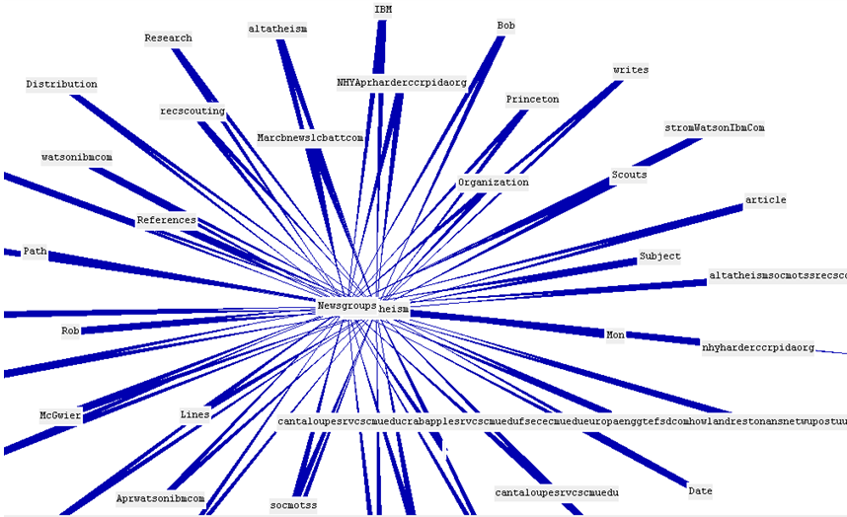

# 20 PhD Project Topics in NLP

1. An innovative mechanism for Preliminary research based on Fundamental Thai NLP Tasks for User-generated Web Content
2. An effective natural language processing function based on Modeling for Robot-Driven Prototype Automation scheme
3. A new-fangled mechanisms for Keyphrase Extraction such as Topic Identification By Term Frequency and Synonymous Term Grouping system
4. An inventive methodology function for Machine Learning Methods for Assessing Freshness in Hydroponic Produce
5. A new mechanism for Model resource of Handwritten Recognition Based on Artificial Intelligence
6. An innovative mechanism for NLP based on Secure Complaint bot using Onion Routing Algorithm Concealing identities to increase effectiveness of complain bot
7. On the use of effective function based Natural Language Processing on Extract Health-Related Causality from Twitter Messages
8. A fresh mechanism function for Evaluation of Rough Sets Data Preprocessing based on NLP Context-Driven Semantic Analysis with RNN
9. An original mechanism for Crowd-Source Based NLP Corpus based on Bangla into English Translation scheme
10. A new source for Portable Phenotyping System based on Portable Machine-Learning Approach into i2b2 Obesity Challenge scheme
11. An innovative performance for AI Based Chat-Bot Using NLP for Azure Cognitive Services
12. An inventive process for Babelfy-Based on Extraction of Collocations from Turkish Hotel Reviews
13. An efficient mechanism function for ASR And Natural Language Processing scheme
14. A novel method for Pragmatic Markers in Russian Spoken Speech based Experience of Systematization and Annotation for Improvement of NLP Tasks
15. An effective source for Text Summarization intended for Tamil Online Sports News used By NLP scheme
16. An inventive process for NLP and Machine Learning Techniques for Detecting Insulting Comments based on Social Networking Platforms
17. The new process for Sentiment Analysis based on Interview Transcripts of NLP for Quantitative Analysis
18. A novel method for Inflectional Review of Deep Learning based on Natural Language Processing
19. The new-fangled mechanism for Search-Based on Algorithm With Scatter Search Strategy aimed at Automated Test Case Generation of NLP Toolkit
20. An inventive performance for Simple NLP-Based Approach to Support Onboarding and Retention in Open Source Communities